Android Computer Graphics – A basic android game and accompanying java level design tool

Contents

1. Introduction 3

2. Design 3

2.1 General 3

2.1.1 Levels 3

2.1.2 Graphics 3

2.2 Dungeon Sprawl 4

2.3 Dungeon Edit 6

3. Implementation 11

3.1 General 11

3.1.1 Graphics Library 11

3.1.2 Levels.json 12

3.2 Dungeon Sprawl 14

3.2.1 Programming Background 14

3.2.2 Game menu 14

3.2.3 Main Activity 16

3.2.4 GameView 17

3.2.5 Movement Controls 17

3.2.6 Misc 21

3.3 Dungeon Edit 22

3.3.1 Programming Background 22

3.3.2 App constructor and Mouse controls 23

3.3.3 Create Menus 25

3.3.4 editImages method 30

3.3.5 Level.java – LevelElement 32

3.3.6 Saving and Deleting Levels 35

3.3.7 Levels to JSON 38

3.3.8 Misc 39

3.4 Unimplemented Features 40

4. Evaluation 41

5. Personal Conclusions 41

# Introduction

This paper explores how useful creating a level design tool is in comparison to with manually programming the parameters of each level in the game, and the implications of such tools in a wider variety of situations. The factors explored in terms of usefulness were the ease of creating new levels and the time taken to do so.

To investigate this, I created my own rudimentary game for android, which I named *Dungeon Sprawl*. Furthermore, I created a java tool to edit levels, which was called *Dungeon Edit*.

For this paper, a level is defined as a virtual space available to a player, in which they must complete some form of objective. A game generally consists of multiple levels that are designed by the game developer.

This creation of a level design tool is not a unique concept: for example, all Game engines are a more advanced form of this concept. A Game engine is a software framework used for developing video games in general, usually based around having specified graphics libraries and a 2D or 3D rendering engine. Unity is one of the more well-known game engines, and is able to program for both PC and android. Of course, the increased versatility of a game engine also increases the amount of complexity and prior knowledge required to use it in comparison to a level editor. Whilst a level editor might not even require coding knowledge, most Game engines require that the user is able to use some form of coding language.

# Design

## General

### Levels

The project as visualised has two parts: the Dungeon Sprawl application and Dungeon Edit program. Both of these pieces of code must be able to interface with a shared set of levels.

The Dungeon Sprawl application is the game that runs the levels, whilst the Dungeon Edit program allows for the design of these levels. This means that the format of whatever is used for a level file must be in the same format for both programs, to facilitate easy transfer between the two separate parts of the project. I decided to use a JSON file for this; primarily because I was creating the dungeon sprawl project first, and so needed the data to be in a format that was able to be easily editable before Dungeon Edit was created. JSON file formatting is generally seen to be easy for humans to read and write, whilst simultaneously being easy for machines to parse and edit.

Each level has a set of floor tiles that are displayed by default, a player model, a set of walls for the player to move around, and a goal. The player and goal cannot start in the same tile, and the wall tiles cannot be in the same tile as either the player or the goal at all.

The JSON file is designed to always at least have a level called “Default” within it, which is used in Dungeon Edit to create new levels.

### Graphics

I decided that the game would be 2D, with all elements of the game fitting discretely into a 21*12 co-ordinate grid, with a default border of wall tiles, making the playable area be a 19*10 grid. The grid itself also has a slight gap between it and the edges of the screens. I decided to do this as it gives a decent sized play area without having the player ever be uncomfortably close to the edge of the screen. This is less pronounced with Dungeon Edit, as the user can move around the window so that it fits their personal preference, but there is still a small border of unused space in the JPanel.

I decided to render this grid as if from an oblique angle: This makes it so that we see part of the side of all walls and can see more of the player then just the top of their head.

I also decided to have two separate floor tile designs per level, to make it so that it was easier to see the boundaries of each grid square within the game. Each level also had options for the appearance of wall tiles, the player, and the goal. Each of these appearances would be the same for every such item in the level, so every wall tile would look the same in one level, but not another.

I also decided to have the player have a different appearance based on what direction it was attempting to travel in. However, all of the differing appearances were kept in discrete image files, that connected all of matching player models together.



## Dungeon Sprawl

Dungeon Sprawl is the android app that provides gameplay to the user. It has two main purposes –allowing a user to select which level they were going to play, and actually playing that level. For the entirety of the app, the orientation is locked to be vertical, in order to prevent scaling issues that would occur for the grid if it was rotated.

I decided early on that I would only create a basic UI for the purposes of selecting which level was going to be loaded for the user, as the main purpose of my project is based around the playing and editing of the actual levels. The UI I created loads all of the names of levels in the JSON file, creating individual buttons for each of them.

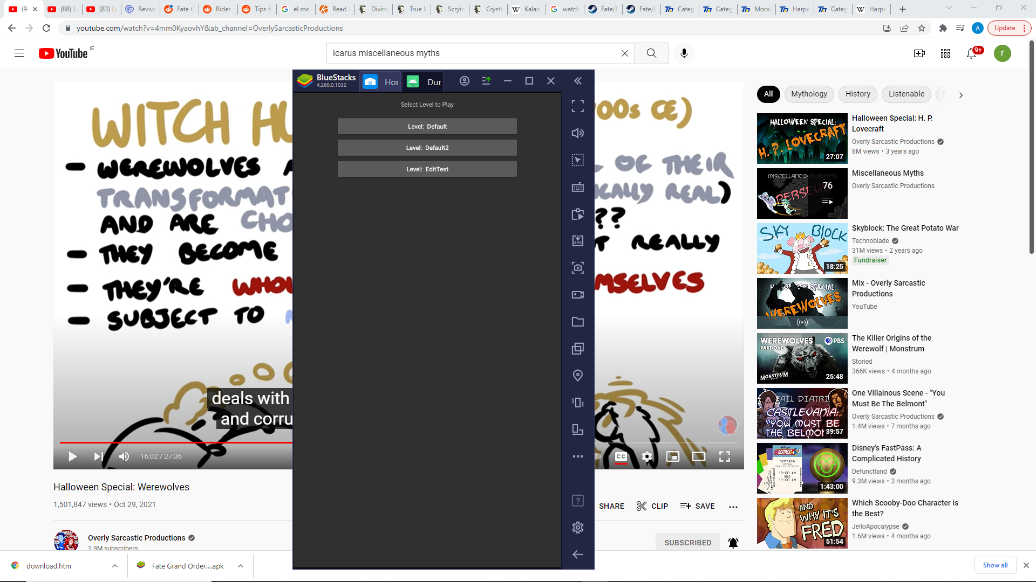

*Level Select Menu*

The buttons then change a global variable to the level name they represent, which is used by the app to select which level is going to be loaded. However, there is nothing more to the menu in this application. I could have perhaps added a multi-level menu, with other options such as Game options or a way to quit the game in it, but as the menu was not the focus of the project, only a rudimentary one that allowed for the user to choose any level created by the level editor.

The other part of the design for this part of the project was the actual gameplay part of the levels. Almost all of the gameplay is built around the players movement. The user controls the player avatar icon, which moves one grid square every 200ms, or 5 grid squares per second. This was judged to be a time interval that would be mildly difficult to make accurate movements with, which is essential when adding perceived difficulty to a game.

The player avatar changes what it looks like based upon which direction it is attempting to move. This is a simple method for users to be able to figure out what direction it will travel in. The orientation of the player itself is controlled by swiping the androids screen in the direction the user wishes the player to move in. This also adds to the perceived difficulty of the game, as it is mildly difficult to get the timing right for a change in direction by using a swiping motion, especially as the swipe must complete within the 200ms interval if accurate movement is desired.

There are two objects with which the player will interact with; the first is a wall tile. The player will stop moving if the tile it is facing is a wall tile. This gives the illusion of solidarity to the wall tiles, as the player cannot pass through them. The other object that the player interacts with is the goal tile. Whenever the player model intersects the goal tile, the player stops moving, and a small menu appears to indicate to the user that the level has been successfully completed and provide a simple way to navigate back to the level selection menu.

## Dungeon Edit

The design of the Dungeon Edit Java program is graphically simplistic, but functional. Upon first opening the program, the JPanel interface is used to display the default level option, along with a variety of menu options

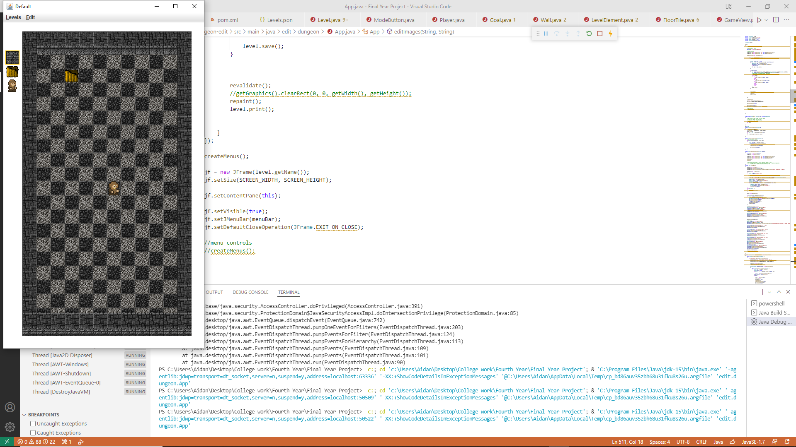

*Dungeon Edit*

Nothing on this window will change without the users input, unlike the Dungeon Sprawl app, which would have the player model move without input, as long as it has an unobstructed floor tile in front of it. Instead, all sprites stay the same without user interaction. Indeed, the player model will always face right by default.

In the project, there are three icons that are used to change how the user interacts with the level selected. These icons will always reflect the current appearance of the elements they represent – the wall tiles, the goal tile and the player avatar, and clicking on them will change what mode the program is operating in: wall placement, goal location, or player location mode. By default, the Dungeon sprawl program is in wall placement mode, which can also be changed to by clicking the icon corresponding to the appearance of the wall tile front.



*Player interaction mode buttons*

In wall mode, each click of the mouse on the window will cause the floor tile clicked to become a wall tile instead, and vice versa. This allows the user to easily change the shape of the level.

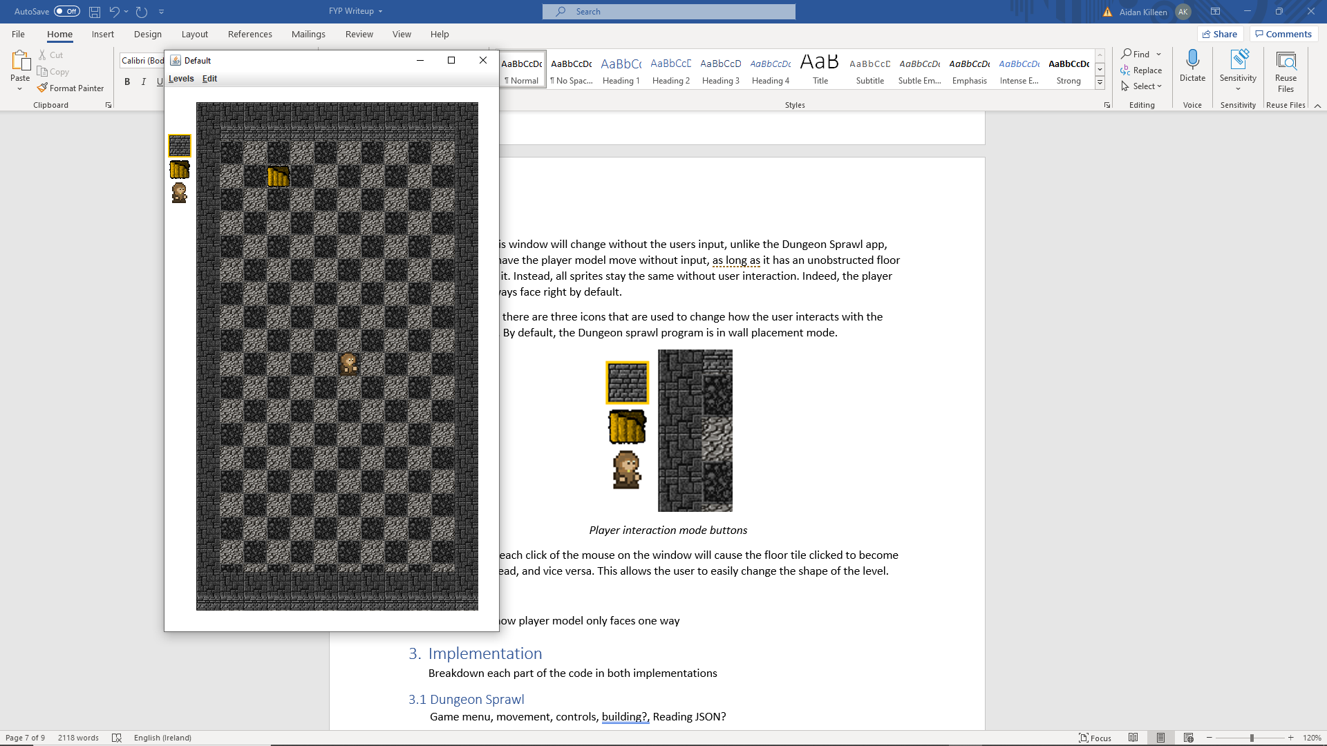

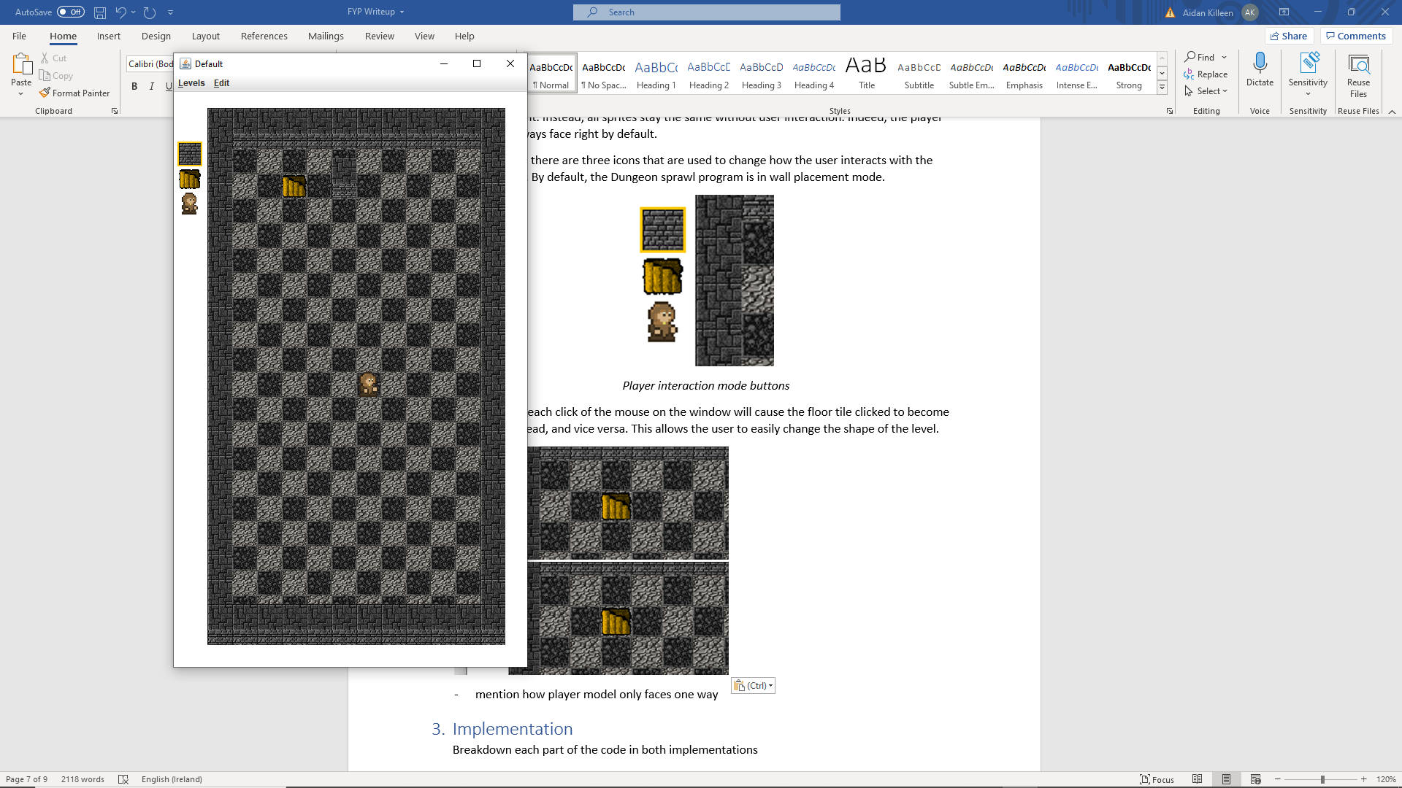

*Wall placement mode example*

If the goal location icon is clicked, the program changes into goal location mode. When the program is in this mode, clicks made by the user on any floor tile location will cause the goal tile to be moved to the clicked location. If the location is occupied by a wall tile, the wall tile will be deleted on the first click of its location, and then the goal can change location on the next click, as per its default behaviour.

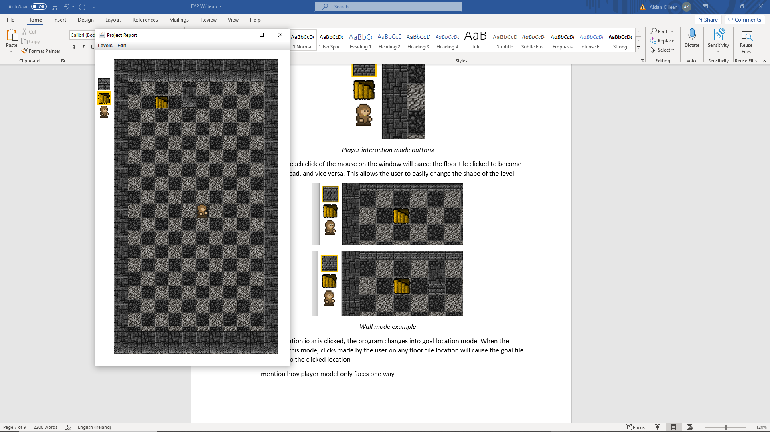

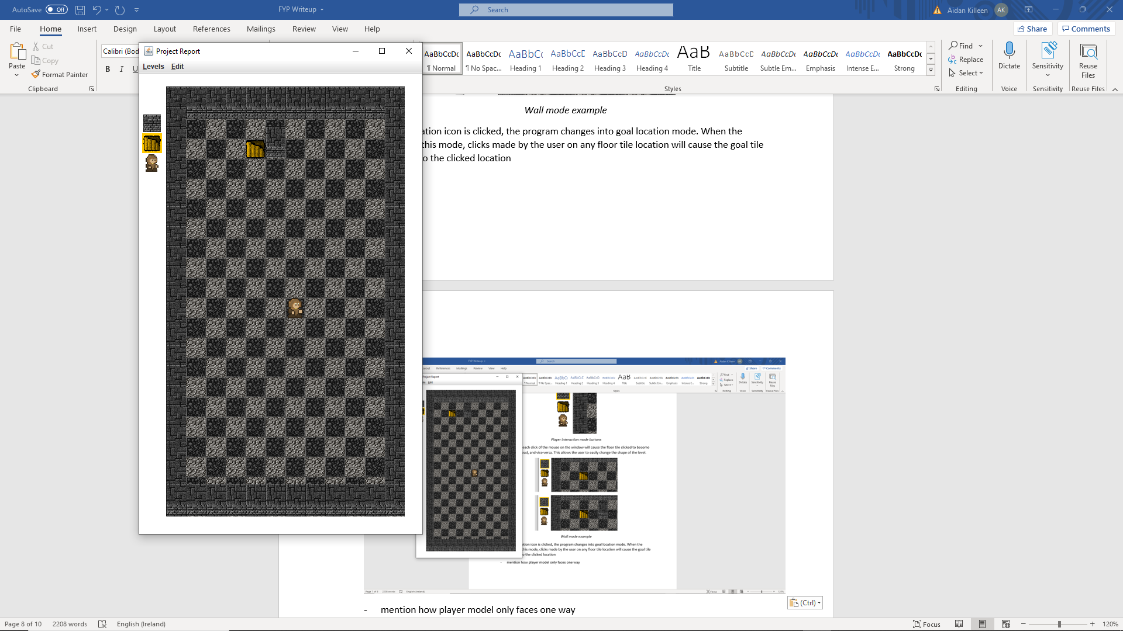

*Goal Location mode example*

Finally, if the player location icon is clicked, the program changes into player location mode. This is similar to the goal location mode, as in this mode clicks made by the user change the location of the player’s starting position. Again, clicking on a square occupied by a wall tile whilst in this mode causes it to be deleted first, after which the player’s location can be swapped to the location.

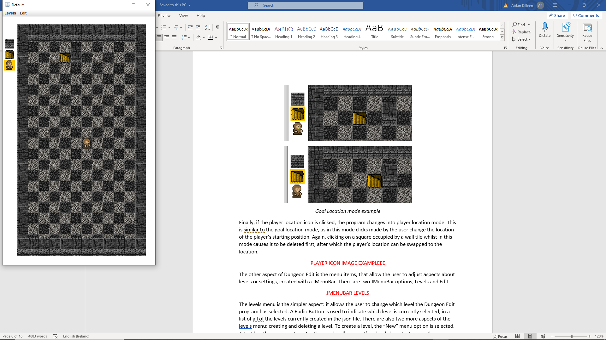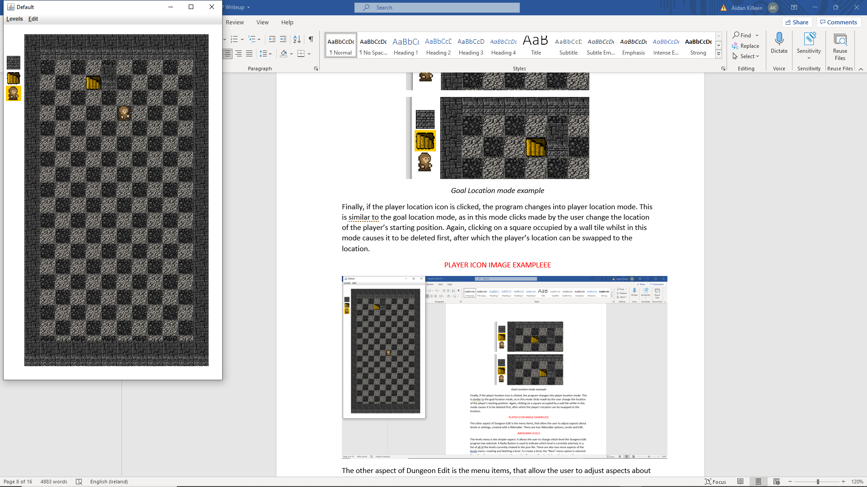

*Player Location Mode Example*

The other aspect of Dungeon Edit is the menu items, that allow the user to adjust aspects about levels or settings, created with a JMenuBar. There are two JMenuBar options, Levels and Edit.

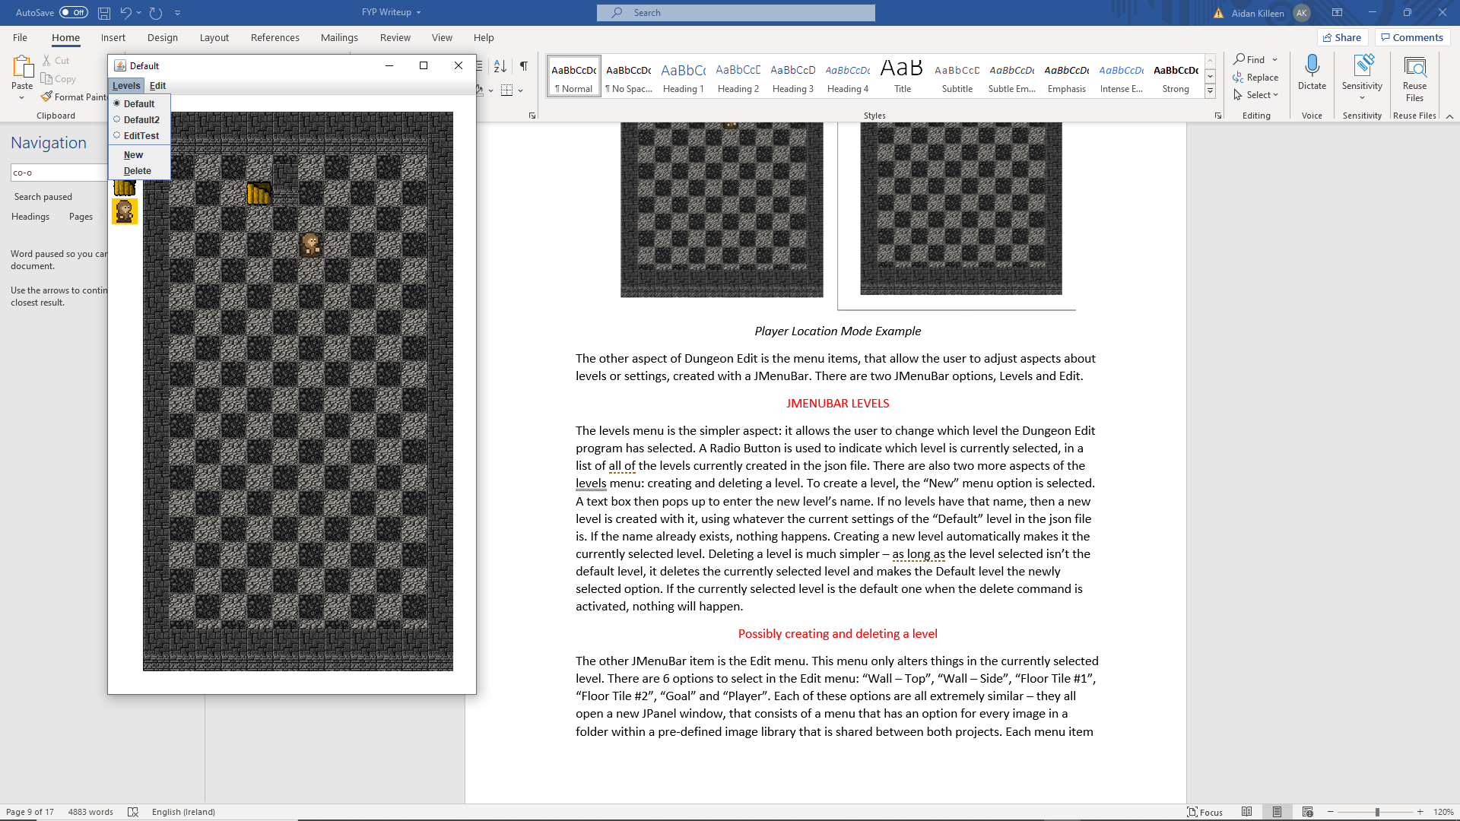

*JMenuBar Levels Example*

The levels menu is the simpler aspect: it allows the user to change which level the Dungeon Edit program has selected. A Radio Button is used to indicate which level is currently selected, in a list of all of the levels currently created in the json file. There are also two more aspects of the levels menu: creating and deleting a level. To create a level, the “New” menu option is selected. A text box then pops up to enter the new level’s name. If no levels have that name, then a new level is created with it, using whatever the current settings of the “Default” level in the json file is. If the name already exists, nothing happens. Creating a new level automatically makes it the currently selected level. Deleting a level is much simpler – as long as the level selected isn’t the default level, it deletes the currently selected level and makes the Default level the newly selected option. If the currently selected level is the default one when the delete command is activated, nothing will happen.

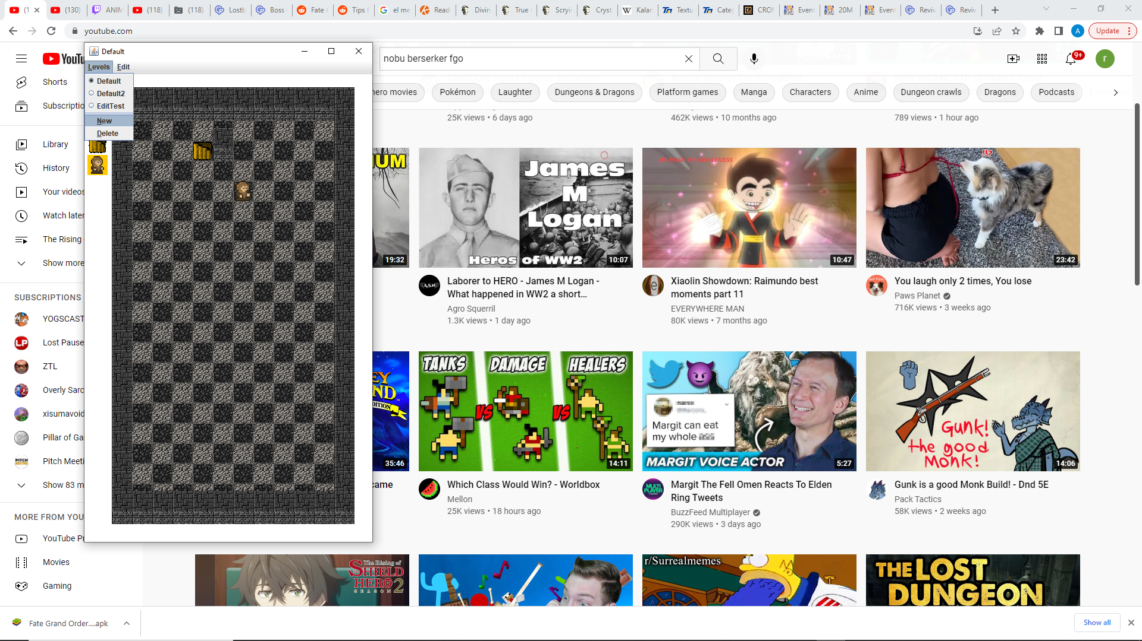

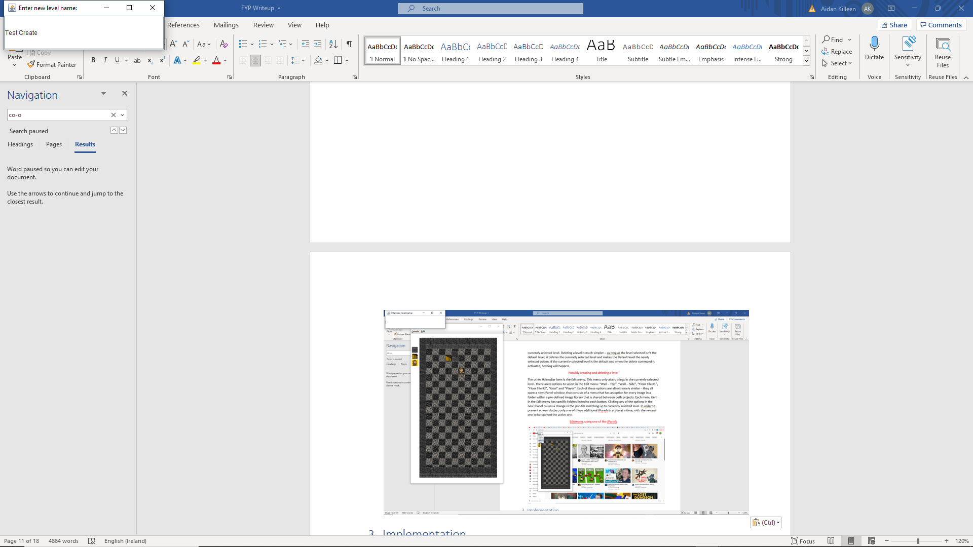

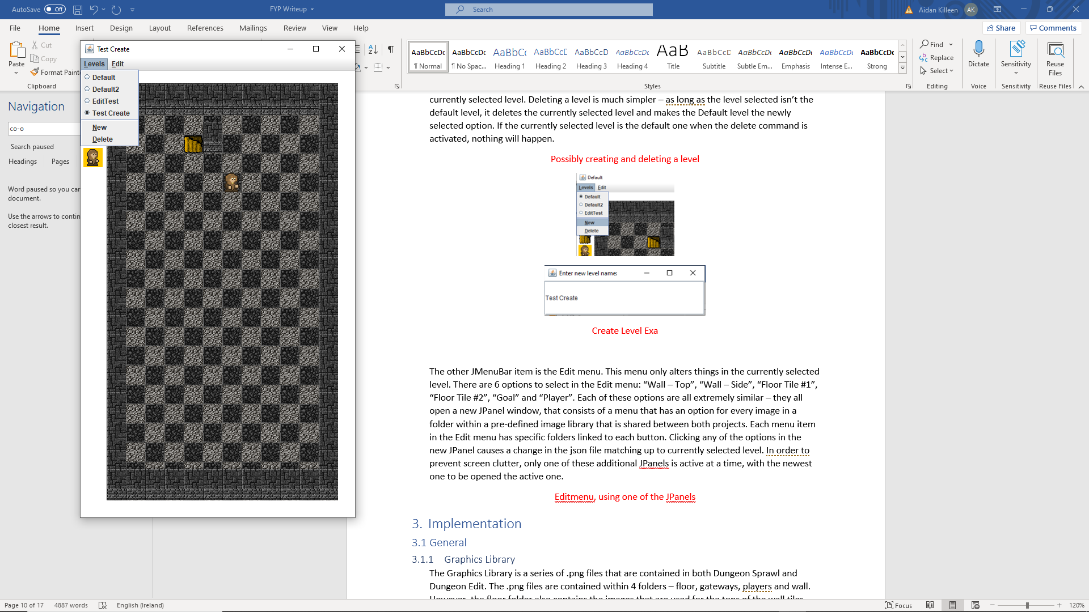

*Create Level Example*

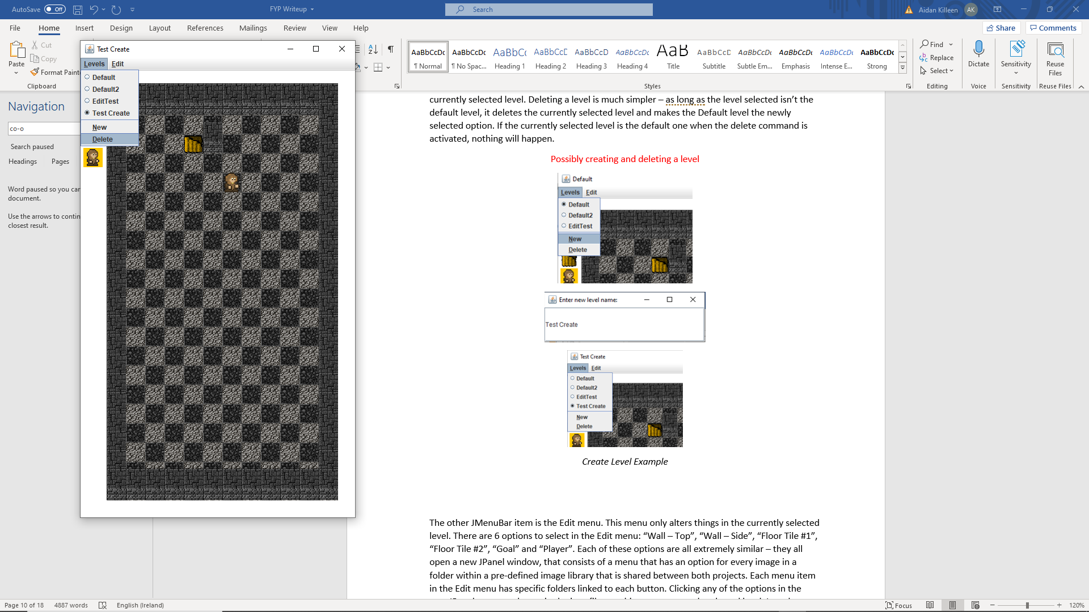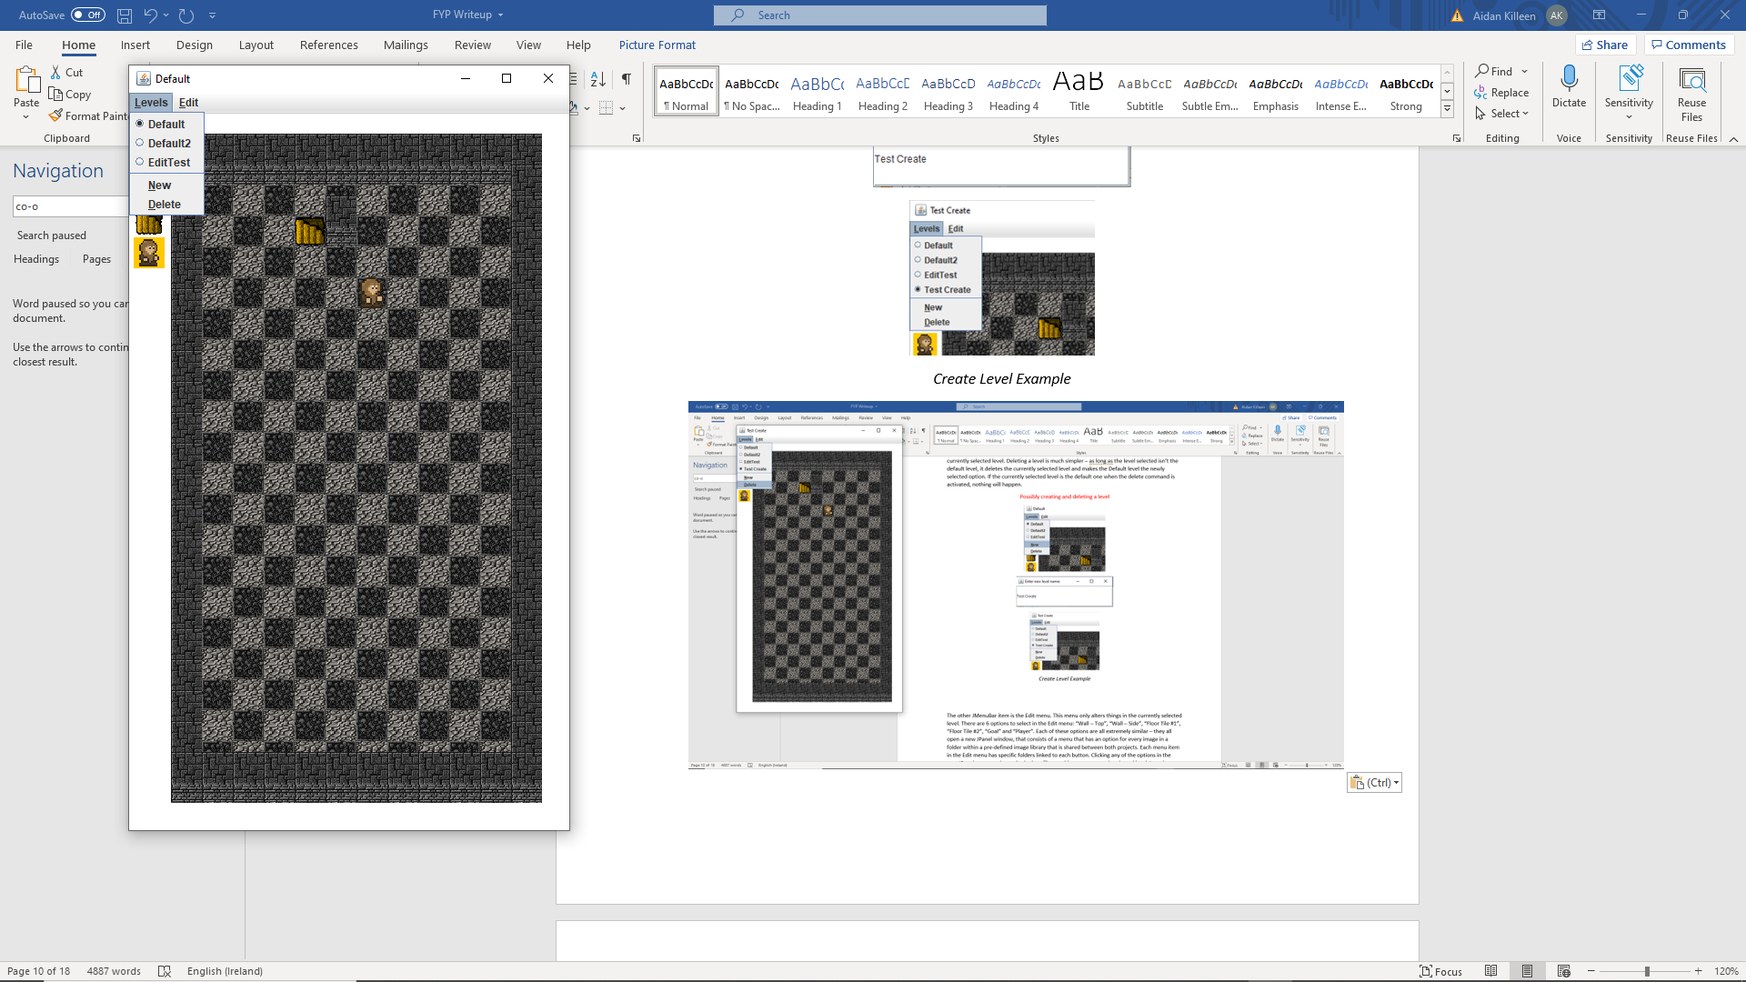

*Delete Level Example*

The other JMenuBar item is the Edit menu. This menu only alters things in the currently selected level. There are 6 options to select in the Edit menu: “Wall – Top”, “Wall – Side”, “Floor Tile #1”, “Floor Tile #2”, “Goal” and “Player”. Each of these options are all extremely similar – they all open a new JPanel window, that consists of a menu that has an option for every image in a folder within a pre-defined image library that is shared between both projects. Each menu item in the Edit menu has specific folders linked to each button. Clicking any of the options in the new JPanel causes a change in the json file matching up to currently selected level. In order to prevent screen clutter, only one of these additional JPanels is active at a time, with the newest one to be opened the active one.

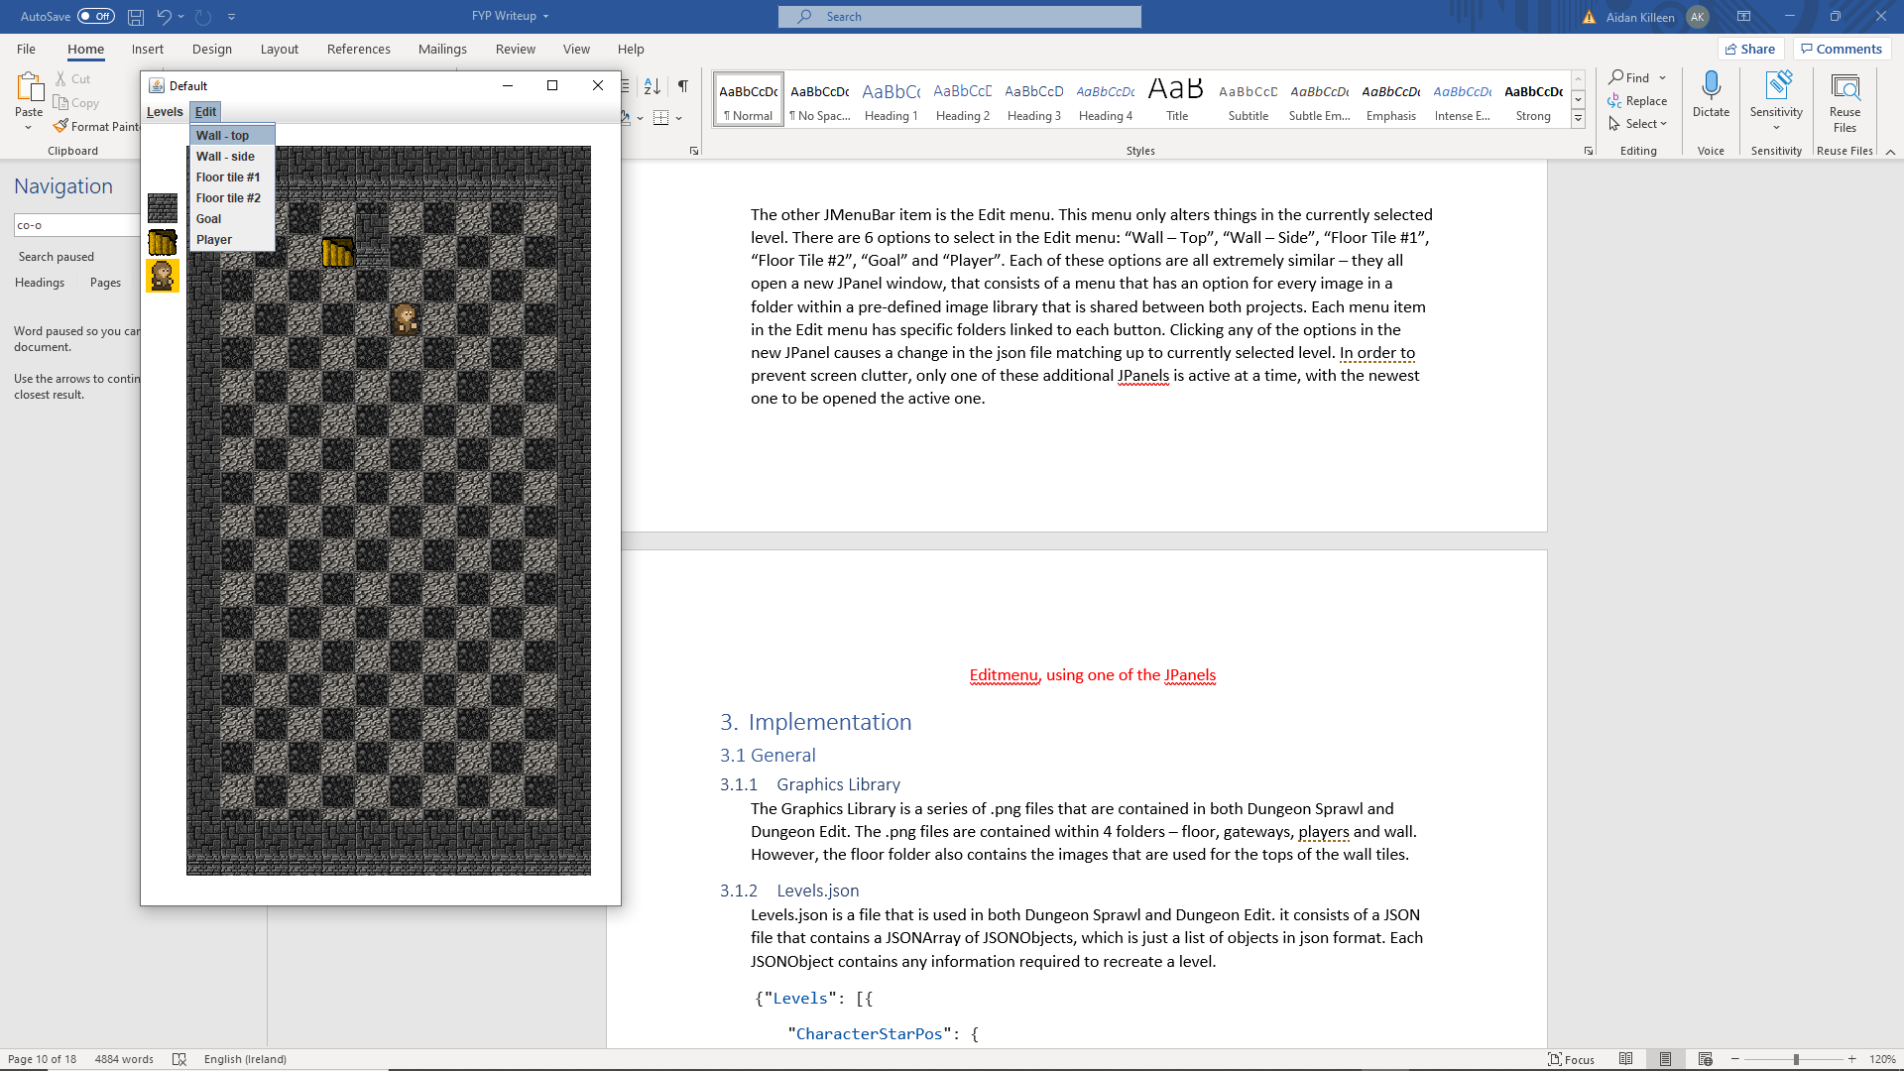

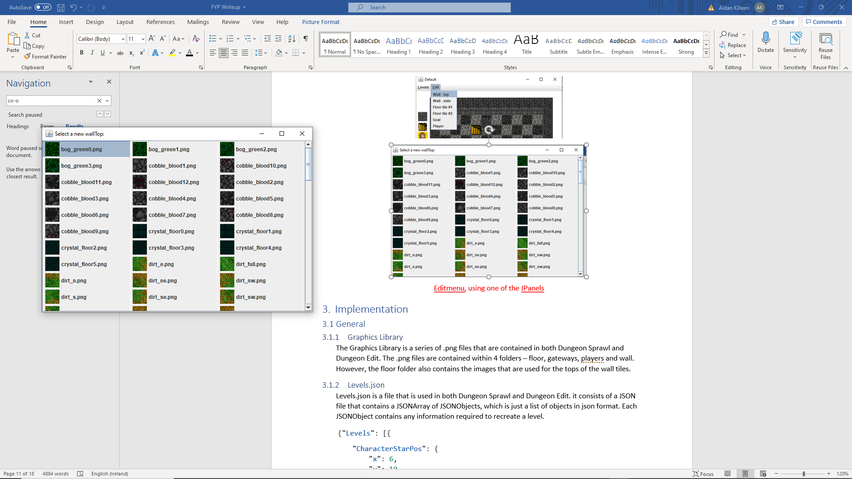

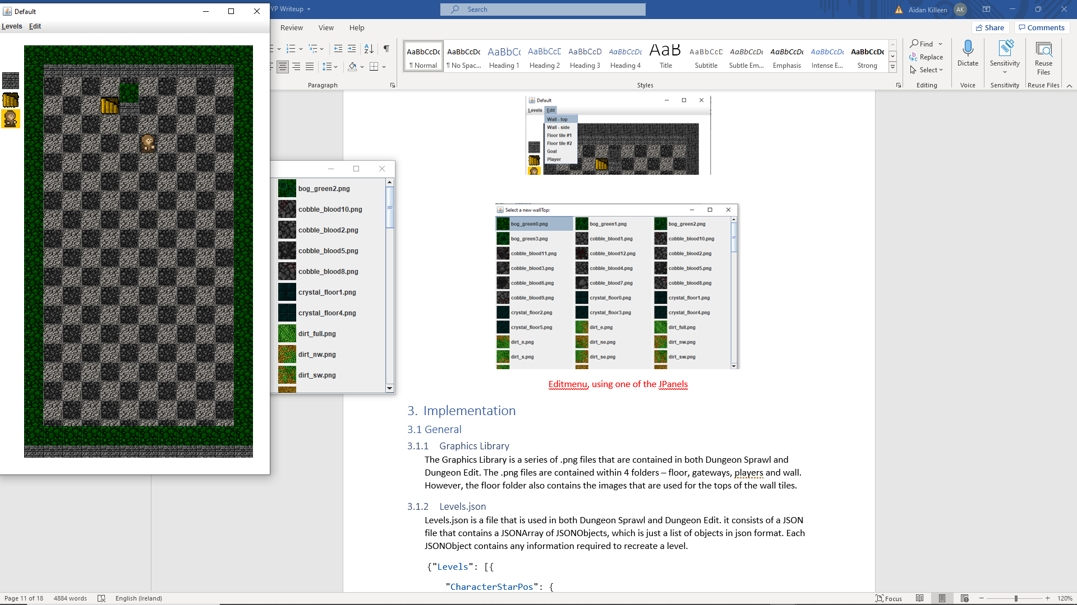

*JMenuBar Edit – Wall – top Example*

# Implementation

## General

### Graphics Library

The Graphics Library is a series of .png files that are contained in both Dungeon Sprawl and Dungeon Edit. The .png files are contained within 4 folders – floor, gateways, players and wall. However, the floor folder also contains the images that are used for the tops of the wall tiles.

### Levels.json

Levels.json is a file that is used in both Dungeon Sprawl and Dungeon Edit. it consists of a JSON file that contains a JSONArray of JSONObjects, which is just a list of objects in json format. Each JSONObject contains any information required to recreate a level.

{"Levels": [{

    "CharacterStarPos": {

        "x": 6,

        "y": 10

    },

    "Floor1PNG": "floor/tomb1.png",

    "Floor2PNG": "floor/pedestal_full.png",

    "GoalPNG": "gateways/dngn_enter.png",

    "GoalPos": {

        "x": 3,

        "y": 2

    },

    "LevelName": "Default",

    "PlayerPNG": "players/player0.png",

    "WallCoords": [],

    "WallTopPNG": "floor/rect_gray0.png",

    "WallVertPNG": "wall/brick_gray1.png"

}]}

Here we see the Layout of a Levels.json file that contains only one entry, a Level called Default. This is the exact contents of Levels.json that the Dungeon Edit program will create if no pre-existing Levels.json file exits.

Each Level JSONObject contains the 10 entries shown above: 6 entries listing references to parts of the Graphical library, one entry listing the name of the level, and 3 entries involving coordinates. This might not be obvious here, as in this example the WallCoords entry is empty in the above example.

{"Levels": [

{

        "CharacterStarPos": {

            "x": 6,

            "y": 10

        },

        "Floor1PNG": "floor/tomb1.png",

        "Floor2PNG": "floor/pedestal_full.png",

        "GoalPNG": "gateways/dngn_enter.png",

        "GoalPos": {

            "x": 3,

            "y": 2

        },

        "LevelName": "Default",

        "PlayerPNG": "players/player0.png",

        "WallCoords": [

            {

                "x": 0,

                "y": 0

            },

            {

                "x": 1,

                "y": 0

            }

        ],

        "WallTopPNG": "floor/rect_gray0.png",

        "WallVertPNG": "wall/brick_gray1.png"

    },

    {

        "CharacterStarPos": {

            "x": 4,

            "y": 16

        },

        "Floor1PNG": "floor/lava1.png",

        "Floor2PNG": "floor/pebble_brown8.png",

        "GoalPNG": "gateways/dngn_enter.png",

        "GoalPos": {

            "x": 8,

            "y": 11

        },

        "LevelName": "Default2",

        "PlayerPNG": "players/player2.png",

        "WallCoords": [

            {

                "x": 6,

                "y": 12

            },

            {

                "x": 7,

                "y": 12

            },

            {

                "x": 4,

                "y": 14

            },

            {

                "x": 4,

                "y": 15

            }

        ],

        "WallTopPNG": "floor/snake1.png",

        "WallVertPNG": "wall/lair0.png"

    }

]}

Above is a second example containing two levels, where the WallCoords JSONArray has been used. As we can see, adding entries to the WallCoords array does not affect the format of the rest of the level JSONObject. The “Default2” Level also loads different parts of the Graphics library in order to create a level that looks different.

Whilst the above examples are informative, for the example Levels.json used with the compiled Dungeon Sprawl apk, each level JSONObject has a set of WallCoords that causes the outermost ring of coordinates to all be Wall tiles, for aesthetic reasons. This version of Levels.json will not be given as an example, as this is the equivalent of 62 entries just in the WallCoords section, which is not a particularly interesting or informative example to look at.

## Dungeon Sprawl

### Programming Background



The android game created was programmed using the free IDE Android Studio. Android studio uses a combination of xml files and java code in order to form all of the layouts and behaviours of the apps. In order to test the resultant code, the Bluestacks android emulator was used, as using the built in emulator from Android Studio caused the IDE to lag.

The code itself was split over 8 java files: Constants.java, FloorTile.java, GameView.java, Goal.java, MainActivity.java, Menu.java, PlayerModel.java, and Wall.java. In addition to these java files, two custom xml files were used to dictate the layout of the android app: activity_main.xml and activity_menu.xml. Finally, the graphical library and the Levels.json files were part of the assets folder. All other files within the code were created by default by Android Studio, so whilst many may contribute to the program working, none of them are parts of the program created by me, and thus they shall not be explored in this section. The Constants.java file just holds some global static variables, so will not be explored in this paper.

The code for Dungeon Sprawl initial opens in the Menu.java file

### Game menu

The Level select menu is the first thing that a user opening an app sees and is one of the more unique parts of code. Most of the code to create this menu takes place in the test() method.

    private void test()

    {

        linear = (LinearLayout) findViewById(R.id.linear);

        InputStream is = null;

        try {

            //create buttons for each entry in levels file

            String data = "Levels.json";

            is = this.getResources().getAssets().open(data);

            int size = is.available();

            byte[] buffer = new byte[size];

            is.read(buffer);

            is.close();

            String json = new String(buffer, "UTF-8");

            JSONObject obj = new JSONObject(json);

            JSONArray levels = obj.getJSONArray("Levels");

            for (int i = 0; i < levels.length(); i++)

            {

                JSONObject temp = levels.getJSONObject(i);

                String tempName = temp.getString("LevelName");

                Button tempB = new Button(this);

                tempB.setHeight(50);

                tempB.setWidth(50);

                tempB.setTag(tempName);

                tempB.setText("Level:  " + tempName);

                tempB.setAllCaps(false);

                tempB.setOnClickListener(btnClicked);

                linear.addView(tempB);

            }

        }

        catch(Exception e)

        {

            Toast.makeText(getApplicationContext(), "An Error has occured",

Toast.LENGTH_SHORT).show();

        }

The main focus of this method is to create a button for each level entry in the Levels.json file. All of the code within the try statement until the for loop is part of the method to extract the levels from the JSON file. However, it is in the for loop that we see something interesting.

Firstly, each button created in this part of the file uses setTag() with the name of the level that it corresponds with. This is used in the btnClicked Listener to set a static global variable that is used in another file to decide which level is going to be displayed. Each button always changes the active View to be the MainActivity.class, regardless of which button was actually pressed.

The more interesting aspect however, is the linear.addView(tempB) line. The linear variable is a global variable for the menu class, that is member of the LinearLayout class, and at the start of the test method is set to be linked to a View. The exact view was set up in Menu.java’s onCreate method, and is the activity_main.xml file.

<ScrollView

        android:layout_width="409dp"

        android:layout_height="800dp"

        android:layout_marginTop="16dp"

        app:layout_constraintEnd_toEndOf="parent"

        app:layout_constraintStart_toStartOf="parent"

        app:layout_constraintTop_toBottomOf="@+id/textView">

        <LinearLayout

            android:id="@+id/linear"

            android:layout_width="match_parent"

            android:layout_height="wrap_content"

            android:textAllCaps="false"

            android:orientation="vertical" />

    </ScrollView>

Above is the part of activity_main.xml that is relevant. The id, “linear” that is referred to in the test() method is a sub part of a ScrollView class. This is relevant, as when combined, it means that every button added to the linear layout in the for loop will list every button in a neat manner, and the user can scroll along the buttons if more levels then can be viewed on one screen appear. This allows the menu to be infinitely scalable.

### Main Activity

The MainActivity.java file is actually quite sparsely populated. In fact, it only has two methods: an onCreate method, and a returnMenu method. The most important aspect of the MainActivity.java file is in fact setting the level complete menu up.

        //creates success button and message in hidden state

        Button menuButton = (Button) findViewById(R.id.menuButton);

        menuButton.setVisibility(View.GONE);

        TextView successMess = findViewById(R.id.sucessMessage);

        successMess.setVisibility(View.GONE);

        GameView.menuButton = menuButton;

        GameView.successText = successMess;

This piece of code makes both of these buttons initially exist in a hidden state. The GameView.java file later on changes them to visible when it loads them.

The more important aspect of the Main activity, is in fact the activity_main.xml file.

<com.example.dungeonsprawl.GameView

        android:id="@+id/gv"

        android:layout_width="match_parent"

        android:layout_height="match_parent"/>

    <Button

        android:id="@+id/menuButton"

        android:layout_width="wrap_content"

        android:layout_height="wrap_content"

        android:onClick="returnMenu"

        android:text="Main Menu"

        app:layout_constraintBottom_toBottomOf="parent"

        app:layout_constraintEnd_toEndOf="parent"

        app:layout_constraintStart_toStartOf="parent"

        app:layout_constraintTop_toTopOf="parent" />

    <TextView

        android:id="@+id/sucessMessage"

        android:layout_width="wrap_content"

        android:layout_height="wrap_content"

        android:layout_marginBottom="10dp"

        android:background="@color/black"

        android:text="Success!"

        android:textColor="@color/white"

        app:layout_constraintBottom_toTopOf="@+id/menuButton"

        app:layout_constraintEnd_toEndOf="parent"

        app:layout_constraintStart_toStartOf="parent" />

Here we see the Button and the Text view referred to earlier on, but we also see the most important part of the activity_main.xml: the invocation of the GameView.java class. It is in that class that most of the important mechanics of the Dungeon Sprawl application occur.

### GameView

The first interesting aspect of the GameView code is a callback to the earlier Menu.java file

        String levelName = Menu.levelToLoad;

The global static variable that the earlier button press set is now used in order to pick out which level is going to be loaded. The way used to do so is fairly simple:

            JSONObject currentLevel = null;

            for (int i = 0; i < levels.length() && currentLevel == null; i++)

            {

                JSONObject temp = levels.getJSONObject(i);

                String tempName = temp.getString("LevelName");

                if(tempName.equals(levelName))

                    currentLevel = temp;

            }

However, there is no way that this for loop will fail to find the appropriate level, as the levelName variable is a string that was fetched from the Levels.json file earlier.

Most of the rest of the code used for GameView is fairly generic, as it is mostly just extracting filepaths and coordinates from the Levels.json file, followed by loading the corresponding .png files from the graphics library to global arrays of Wall.java, FloorTile.java and individual global variables for PlayerModel.java and Goal.java.

However there is one more important aspect of the GameView file, and that is the movement controls.

### Movement Controls

The movement controls for Dungeon Sprawl’s gameplay are mostly contained within the GameView.java file, but also spread to the PlayerModel.java as well.

The first part of the controls sets what direction the PlayerModel will actually attempt to move in, and is all held within the onTouchEvent method.

    @Override

    public boolean onTouchEvent(MotionEvent event)

    {

        int a = event.getActionMasked();

        switch (a)

        {

            case MotionEvent.ACTION_MOVE:{

                if(!move)

                {

                    //start of motion

                    mx = event.getX();

                    my = event.getY();

                    move = true;

                }

                else

                {

                    //end of motion

                    if(mx - event.getX() > 100*Constants.SCREEN_WIDTH/1080)

                    {

                        mx = event.getX();

                        my = event.getY();

                        player.setMove_left();

                    }

                    else if(event.getX() - mx >

100*Constants.SCREEN_WIDTH/1080)

                    {

                        mx = event.getX();

                        my = event.getY();

                        player.setMove_right();

                    }

                    else if(my - event.getY() >

100*Constants.SCREEN_WIDTH/1080)

                    {

                        mx = event.getX();

                        my = event.getY();

                        player.setMove_up();

                    }

                    else if(event.getY() - my >

100*Constants.SCREEN_WIDTH/1080)

                    {

                        mx = event.getX();

                        my = event.getY();

                        player.setMove_down();

                    }

                }

                break;

            }

            case MotionEvent.ACTION_UP:{

                //release touch

                mx = 0;

                my = 0;

                move = false;

                break;

            }

        }

        return true;

    }

The onTouchEvent method is triggered whenever someone taps on the screen of an android device. The initial case MotionEvent.ACTION_MOVE: is where most of the directional code takes place. the if(!move) statement only takes place if the screen has just started to be touched, and records the position the screen was touched in. The else statement following it finds out if the current position you are touching the screen is far enough away from the previously recorded position to cause the player to change directions. Moving far enough triggers the following method or similar in the object of the PlayerModel class that GameView is storing globally.

    public void setMove_left()

    {

        setNoMove();

        this.move_left = true;

    }

This method removes all previous directions that the PlayerModel would be facing, and sets the it to be what the latest direction indicated by the onTouchEvent from GameView indicates.

Finally, the case MotionEvent.ACTION_UP resets the onTouchEvent method once the user stops touching the android device.

The other part of the movement controls deal with collision handling, and takes place in the draw() method in GameView.

//draw floor tiles, and find potential tiles player can move to

        for(int i = 0; i < arrFloor.size(); i++)

        {

            canvas.drawBitmap(arrFloor.get(i).getBm(), arrFloor.get(i).getX(),

                    arrFloor.get(i).getY(), null);

            //can only move to tiles within boundaries

            if(arrFloor.get(i).getrBody().intersect(player.getrLeft()))

                canLeft = true;

            if(arrFloor.get(i).getrBody().intersect(player.getrRight()))

                canRight = true;

            if(arrFloor.get(i).getrBody().intersect(player.getrTop()))

                canUp = true;

            if(arrFloor.get(i).getrBody().intersect(player.getrBottom()))

                canDown = true;

        }

        //wall movement rules

        for(int i = 0; i < arrWall.size(); i++)

        {

            //cannot move into a wall

            if(arrWall.get(i).getrBody().intersect(player.getrLeft()))

                canLeft = false;

            if(arrWall.get(i).getrBody().intersect(player.getrRight()))

                canRight = false;

            if(arrWall.get(i).getrBody().intersect(player.getrTop()))

                canUp = false;

            if(arrWall.get(i).getrBody().intersect(player.getrBottom()))

                canDown = false;

        }

        //draw goal

        canvas.drawBitmap(goal.getBm(), goal.getX(),goal.getY(), null);

        if(!player.getrBody().intersect(goal.getrBody()))

            player.update(canLeft, canRight, canUp, canDown);

        else if (firstWin)

        {

            //sets menu button to visable if game is won

            firstWin = false;

            menuButton.setVisibility(View.VISIBLE);

            successText.setVisibility(View.VISIBLE);

        }

        player.draw(canvas);

The movement controls are spread over several different parts of the draw command. In the first for loop, when drawing the floor tiles, a set of four Booleans that are initially false are set to only be true if the player has a neighbouring floor tile. This is done by checking if some virtual rectangles beside the PlayerModel intersect with the rectangles each FloorTile exist within. This part of the code prevents the PlayerModel from moving off the edge of the co-ordinate grid that the game takes place on.

The second for loop uses the same four Booleans to check if any of the neighbouring tiles are wall tiles. This is to prevent the PlayerModel from moving into any tiles already occupied by wall tiles.

The next part of code is the if(!player.getrBody().intersect(goal.getrBody())) statement. This causes the player.update() method to only be called if the player is not already in direct contact with the goal tile. Once that occurs, there is no point in the player moving, as the game is already won.

The next important piece of code for player movement, is the player.update() method in the PlayerModel.java file.

    public void update(boolean canLeft, boolean canRight, boolean canUp,

boolean canDown)

    {

        if(move_right)

        {

            if (canRight)

                setX(getX()+GameView.sizeOfMap);

            bm_current = bm_walk_right;

        }

        else if (move_left)

        {

            if (canLeft)

                setX(getX()-GameView.sizeOfMap);

            bm_current = bm_walk_left;

        }

        else if (move_up)

        {

            if (canUp)

                setY(getY()-GameView.sizeOfMap);

            bm_current = bm_walk_up;

        }

        else if (move_down)

        {

            if (canDown)

                setY(getY()+GameView.sizeOfMap);

            bm_current = bm_walk_down;

        }

    }

This four booleans that are inputs to this method indicate if the PlayerModel should be able to move in a direction, whilst only one of the move_right ect global variables are true at a time, indicating what direction the player is attempting to move. The player will only move in a direction if they are currently trying to, and that direction is unobstructed, adjusting the PlayerModel’s coordinates accordingly.

### Misc

Most of the rest of the code is self-explanatory. The Wall.java, FloorTile.java and Goal.java classes all store the corresponding images and co-ordinates for each iteration that they exist, and when a draw() method is invoked, display the image they contain at the specified location on the canvas. The only place where this becomes complicated is the PlayerModel.java.

    public PlayerModel(Bitmap bm, int sizeOfMap, int x, int y)

    {

        this.bm = bm;

        this.x = x;

        this.y = y;

        int height = bm.getHeight();

        int width = bm.getWidth()/16;

        //divide image

        bm_walk_up = Bitmap.createBitmap(bm, width*2, 0, width, height );

        bm_walk_up = Bitmap.createScaledBitmap(bm_walk_up, sizeOfMap,

sizeOfMap, true);

        bm_walk_down = Bitmap.createBitmap(bm, 0, 0, width, height );

        bm_walk_down = Bitmap.createScaledBitmap(bm_walk_down, sizeOfMap,

sizeOfMap, true);

        bm_walk_left = Bitmap.createBitmap(bm, width*6, 0, width, height );

        bm_walk_left = Bitmap.createScaledBitmap(bm_walk_left, sizeOfMap,

sizeOfMap, true);

        bm_walk_right = Bitmap.createBitmap(bm, width*4, 0, width, height );

        bm_walk_right = Bitmap.createScaledBitmap(bm_walk_right, sizeOfMap,

sizeOfMap, true);

        bm_current = bm_walk_right;

        setMove_right();

    }

The main difference, is that for iterations of the PlayerModel class, multiple subdivisions of the initial .png extracted from the graphics library are made. Here is an example of one of these images:



Notice how the image contains the graphics for the player doing a variety of actions, including the motion images. In the PlayerModel class, the initial image is used to create four sub-images, that are set to be active based on what direction the user has dictated the player is currently moving in. Other then this variation and methods discussed in the Movement Controls section, the PlayerModel class is similar to all of the other component classes of the GameView.

## Dungeon Edit

### Programming Background



The level editor was programmed using the free IDE Visual Studio Code. Visual Studio Code supports a variety of coding languages, but for this project only java code was used to create the program. More specifically, JPanel and its supporting classes JFrame, JMenuBar and JMenu are imported from the javax.swing library is used to provide the graphical feedback to the user. These classes allow for a java program to open a window, which could display the current design of each level.

The code itself is split over 8 java files: App.java, FloorTile.java, Goal.java, Level.java, LevelElement.java, ModeButton.java, Player.java, and Wall.java. The graphical library is part of the resources folder, however the Levels.json file is not in the codes body – instead, the file used when the program is run is in whatever directory the program was run in.

The code for Dungeon Edit initial opens in the App.java file

### App constructor and Mouse controls

The most complex aspect of the Dungeon Edit Project is the App.java file. It also contains an extremely simple main for the compiler, that just creates an iteration of the App class

    public static void main( String[] args ) throws IOException

    {

        new App();

    }

The class constructor invoked is also quite simple.

    App()

    {

        //Error handling - does JSON exist

        String fileName = "Levels.json";

        File jsonFile = new File(fileName);

        boolean fileExists = jsonFile.exists();

        //System.out.println("Json exists: " + fileExists);

        if(!fileExists)

        {

            Level temp = new Level();

            temp.saveNew();

        }

        //opens default level

        this.level = new Level("Default");

        //mouse controls

        arrButtons.add(new ModeButton(2, 'w', this.level.getWallVertImg()));

        arrButtons.add(new ModeButton(3, 'g', this.level.getGoalImg()));

        arrButtons.add(new ModeButton(4, 'p', this.level.playImg()));

        addMouseListener(new MouseAdapter() {

            public void mousePressed(MouseEvent e) {

                boolean buttonPress = false;

                for(int i = 0; i <arrButtons.size() && !buttonPress; i++)

                {

                    ModeButton temp = arrButtons.get(i);

                    buttonPress = temp.clicked(e.getX(), e.getY());

                    if(buttonPress)

                    {

                        mode = temp.mode();

                    }

                }

                if(!buttonPress)

                {

                    int xGrid = (e.getX()-

App.SCREEN_WIDTH/2+(Level.w/2)*Level.sizeOfMap)/Level

.sizeOfMap;

                    int yGrid = (e.getY()-

100*App.SCREEN_HEIGHT/1920)/Level.sizeOfMap;

                    switch (mode)

                    {

                        case 'w':

                            level.setWallTile(xGrid, yGrid);

                        break;

                        case 'p':

                            level.setPlayerTile(xGrid, yGrid);

                        break;

                        case 'g':

                            level.setGoalTile(xGrid, yGrid);

                        break;

                        default:

                        break;

                    }

                    level.save();

                }

                revalidate();

                repaint();

            }

        });

        createMenus();

        jf = new JFrame(level.getName());

        jf.setSize(SCREEN_WIDTH, SCREEN_HEIGHT);

        jf.setContentPane(this);

        jf.setVisible(true);

        jf.setJMenuBar(menuBar);

        jf.setDefaultCloseOperation(JFrame.EXIT_ON_CLOSE);

    }

The first thing that occurs in the class constructor is an error checker for if the Levels.json file exists within the directory this project was invoked from. Without the existence of this file, the entire code won’t work, so if it does not exist, a default file with a very simple level JSONObject is created, using methods that are exclusively used for this purpose. Attempting to use Level() constructor without a level name, or the saveNew method would cause crashes if they were invoked anywhere else in the code.

Until the addMouseListener method is called, the App just sets the active level as the “Default” level, and creates an array of objects of the ModeButton class. These buttons are used to change what clicking on the grid will do in the mousePressed method of the addMouseListener method.

The addMouseListener only consists of the mousePressed method. The first part of the mousePressed method checks if any of the Mode buttons were clicked. If one was, it changes what clicking on the grid will do accordingly. Otherwise, it calculates the corresponding grid position for where the mouse was clicked, and adjusts the active level accordingly. After each change from a click, the level is saved. After any click full stop, the entire JPanel display is revalidated and repainted.

The rest of the App constructor consists of invoking the createMenus method and setting up the variables for the JPanel that displays the level. It also makes it so that if this JPanel is closed, the entire program will end.

### Create Menus

The createMenus method is a part of the App.java file, and overall is one of the more complex pieces of code in the project. The first part of the menu is the Levels JMenuBar option.

        menuBar = new JMenuBar();

        //levels JMenu

        levelOptions = new JMenu("Levels");

        levelOptions.setMnemonic(KeyEvent.VK_L);

        levelOptions.getAccessibleContext().setAccessibleDescription("Select

which level to edit");

        levelList = new ArrayList<>();

        try

        {

            //creates list of level names

            String fileName = "Levels.json";

            String json = new String(Files.readAllBytes(Paths.get(fileName)),

StandardCharsets.UTF_8);

            JSONObject obj = new JSONObject(json);

            JSONArray levels = obj.getJSONArray("Levels");

            JSONObject currentLevel = null;

            for (int i = 0; i < levels.length() && currentLevel == null; i++)

            {

                JSONObject temp = levels.getJSONObject(i);

                String tempName = temp.getString("LevelName");

                levelList.add(tempName);

            }

        }

        catch(Exception e)

        {

            System.out.println(e);

        }

        group = new ButtonGroup();

        //creates buttons in Levels Jmenu for each level name

        for(int i = 0; i < levelList.size(); i++)

        {

            String tempName = levelList.get(i);

            JRadioButtonMenuItem temp = new JRadioButtonMenuItem(tempName);

            temp.setActionCommand(tempName);

            temp.addActionListener(this);

            if(tempName.equals(groupStart))

                temp.setSelected(true);

            levelOptions.add(temp);

            group.add(temp);

        }

        levelOptions.addSeparator();

The above code is fairly self-explanatory – The code in the try block reads all of the level names from the Levels.json file and puts them in a string list. The rest of the code creates a JRadioButtonMenuItem for each of the levels found. This allows the user to see which level is currently selected. The actionListener used for each of these buttons is as follows:

    public void actionPerformed(ActionEvent e)

    {

        //menu navigation actions

        for(int i = 0; i <levelList.size(); i++)

        {

            String levelName = levelList.get(i);

            if(levelName.equals(e.getActionCommand()))

            {

                updateSelectedLevel(levelName);

                jf.setTitle(levelName);

            }

        }

    }

This method checks if the button pressed was a valid level name, and changes the active level to the new Level. It also sets the title of the JPanel to be the new level name.

        //create and delete option in Levels JMenu

        JMenuItem createLevel = new JMenuItem("New");

        createLevel.setMnemonic(KeyEvent.VK_N);

        createLevel.setActionCommand("createLevel");

        createLevel.addActionListener(levelEditOptions);

        levelOptions.add(createLevel);

        JMenuItem deleteLevel = new JMenuItem("Delete");

        deleteLevel.setMnemonic(KeyEvent.VK_D);

        deleteLevel.setActionCommand("deleteLevel");

        deleteLevel.addActionListener(levelEditOptions);

        levelOptions.add(deleteLevel);

        menuBar.add(levelOptions);

Above is the rest of the JMenuItems added under the “Levels” heading of the JMenuOptionBar. They are fairly simple, however they use the same action listener as the all of the options within the “Edit” heading.

        //Edit JMenu

        JMenu editOptions = new JMenu("Edit");

        editOptions.setMnemonic(KeyEvent.VK_E);

        editOptions.getAccessibleContext().setAccessibleDescription("Choose a

part of the level to change the graphics of");

        JMenuItem wallTop = new JMenuItem("Wall - top");

        wallTop.setActionCommand("wallTop");

        wallTop.addActionListener(levelEditOptions);

        editOptions.add(wallTop);

        JMenuItem wallSide = new JMenuItem("Wall - side");

        wallSide.setActionCommand("wallVert");

        wallSide.addActionListener(levelEditOptions);

        editOptions.add(wallSide);

        JMenuItem floor1 = new JMenuItem("Floor tile #1");

        floor1.setActionCommand("floor1");

        floor1.addActionListener(levelEditOptions);

        editOptions.add(floor1);

        JMenuItem floor2 = new JMenuItem("Floor tile #2");

        floor2.setActionCommand("floor2");

        floor2.addActionListener(levelEditOptions);

        editOptions.add(floor2);

        JMenuItem goal = new JMenuItem("Goal");

        goal.setActionCommand("goal");

        goal.addActionListener(levelEditOptions);

        editOptions.add(goal);

        JMenuItem playerModel = new JMenuItem("Player");

        playerModel.setActionCommand("player");

        playerModel.addActionListener(levelEditOptions);

        editOptions.add(playerModel);

        menuBar.add(editOptions);

    }

The rest of the createMenus method is fairly simplistic, and just creates the options for the “Edit” heading of the toolbar. However, things rapidly get more complex when the levelEditOptions action listener is taken into account.

    //action listener for

    private ActionListener levelEditOptions = new ActionListener()

    {

        public void actionPerformed(ActionEvent e)

        {

            if("createLevel".equals(e.getActionCommand()))

            {

                newLevelEnter = new JFrame("Enter new level name:");

                newLevelEnter.setDefaultCloseOperation(JFrame.DISPOSE_ON_CLOSE

);

                newLevelEnter.setSize(SCREEN_WIDTH/3*2, SCREEN_HEIGHT/8);

                textField = new JTextField(20);

                newLevelEnter.add(textField);

                //textField.addActionListener(this);

                ActionListener newLevelListener = new ActionListener()

                {

                    public void actionPerformed(ActionEvent e)

                    {

                        String text = textField.getText();

                        boolean valid = true;

                        for(int i = 0; i < levelList.size() && valid; i++)

                        {

                            valid = !text.equals(levelList.get(i));

                        }

                        valid = valid && !text.equals("");

                        if(valid)

                        {

                            level = new Level(text);

                            level.save();

                            groupStart = text;

                            createMenus();

                            updateSelectedLevel(text);

                            jf.setJMenuBar(menuBar);

                            jf.setTitle(text);

                        }

                        newLevelEnter.dispose();

                    }

                };

                textField.addActionListener(newLevelListener);

                newLevelEnter.setVisible(true);

            }

            else if("deleteLevel".equals(e.getActionCommand()))

            {

                if(!level.getName().equals("Default"))

                {

                    level.delete();

                    level = new Level("Default");

                    groupStart = "Default";

                    createMenus();

                    updateSelectedLevel("Default");

                    jf.setJMenuBar(menuBar);

                    jf.setTitle("Default");

                }

            }

The createLevel action command is from the “Levels” heading, and looks complicated, but is simple in functionality. It opens a new JPanel that consists of only a text field. Once the enter key is pressed, it checks if any other level is called what was entered, or if no text was entered at all. If the string retrieved has not been used before, and actually is valid text, a new level is created, the menubars are updated, and the currently selected level is set to be the new one. Finally, the new JPanel is deleted.

The deleteLevel action command is much simpler. It just invokes the delete command for the currently selected level, and then changes the currently selected level to be the default, after updating the menus.

            else if ("wallTop".equals(e.getActionCommand())

||"floor1".equals(e.getActionCommand())

|| "floor2".equals(e.getActionCommand()))

            {

                String location = "floor";

                String type = e.getActionCommand();

                editImages(location, type);

            }

            else if("wallVert".equals(e.getActionCommand()))

            {

                String location = "wall";

                String type = "wallVert";

                editImages(location, type);

            }

            else if("goal".equals(e.getActionCommand()))

            {

                String location = "gateways";

                String type = "goal";

                editImages(location, type);

            }

            else if("player".equals(e.getActionCommand()))

            {

                String location = "players";

                String type = "player";

                editImages(location, type);

            }

        }

    };

The rest of the action commands are all similar enough to be able to use a similar method called editImages. This method involves opening a new JPanel, and selecting a new image from it. However, each invocation needs to be specific for which part of the graphics library is invoked, which is what the location String in each of the else statements refers to. This method is further broken down in the next section.

### editImages method

    //create JPanel for editing parts of Levels.json

    private void editImages(String location, String type)

    {

        ClassLoader classloader =

Thread.currentThread().getContextClassLoader();

        if(traitEdit != null)

            traitEdit.dispose();

        traitEdit = new JFrame("Select a new " + type + ":");

        traitEdit.setSize(SCREEN_WIDTH+SCREEN_WIDTH/4, SCREEN_HEIGHT/2);

        traitEdit.setDefaultCloseOperation(JFrame.DISPOSE_ON_CLOSE);

        try(

            final InputStream is = classloader.getResourceAsStream(location);

            final InputStreamReader isr = new InputStreamReader(is,

StandardCharsets.UTF_8);

            final BufferedReader br = new BufferedReader(isr))

        {

            String s = null;

            ActionListener l = varAL(type);

            JPanel panel = new JPanel(new GridLayout(0,3));

            while ((s=br.readLine()) != null)

            {

                if(s.contains(".png"))

                {

                    //invokes action commands using file names

                    Icon itemImg = new

ImageIcon(ImageIO.read(classloader.

getResourceAsStream(location + "/" + s)));

                    JMenuItem item = new JMenuItem(s, itemImg);

                    item.setActionCommand(location + "/" + s);

                    item.addActionListener(l);

                    panel.add(item);

                }

            }

            JScrollPane scrollPane = new JScrollPane(panel);

            scrollPane.getVerticalScrollBar().setUnitIncrement(16);

            traitEdit.add(scrollPane);

            traitEdit.setVisible(true);

        }

        catch (Exception e3)

        {

            System.out.println(e3);

        }

    }

The editImages method is used in order to change the graphics of the currently active level. It uses a global JPanel, trait edit to accomplish this. The first thing this method does is check if the traitEdit JPanel is already open, from a previous invocation of editImages. If it is, it closes the JPanel, as otherwise it cannot be used. The reason for only using a single global JPanel is to prevent an excessive amount of windows being opened by the Dungeon Edit program. The next thing done is to apply the settings for the new traitEdit JPanel.

The try block is the most important part of the editImages method. It opens the folder from the graphics library provided by the levelEditOptions action listener, and lists all of the files within that folder. Then the varAL action listener method is invoked, which changes what exactly it does based on the “type” string variable provided.

    //action listener that changes what action it does based on what menu it is created for

    private ActionListener varAL(String mode)

    {

        //all action commands invoked will be file names/locations

        final String mode2 = mode;

        return new ActionListener() {

            public void actionPerformed(ActionEvent e) {

                if(mode2.equals("wallTop"))

                {

                    level.setWallTopImg(e.getActionCommand());

                }

                else if(mode2.equals("wallVert"))

                {

                    level.setWallVertImg(e.getActionCommand());

                }

                else if(mode2.equals("goal"))

                {

                    level.setGoalImg(e.getActionCommand());

                }

                else if(mode2.equals("floor1"))

                {

                    level.setFloor1Img(e.getActionCommand());

                }

                else if(mode2.equals("floor2"))

                {

                    level.setFloor2Img(e.getActionCommand());

                }

                else if(mode2.equals("player"))

                {

                    level.setPlayerImg(e.getActionCommand());

                }

                level.save();

                updateSelectedLevel(level.getName());

            }

        };

    }

Depending on what type was provided, the varAL will change a different part of the level file. In the editImages method, the action command of each button is set to be the new address for the edited part of the level, so the varAL is fairly simple. The buttons created for the JFrame also have a preview of the changed image, making the buttons more informative.

editImages also sets up the JPanel to be on a scroll pane, so all of the possible buttons are able to be seen.

### Level.java – LevelElement

Most of the Level(“LevelName”) constructor is similar to previously explored code, or even the GameView.java file from Dungeon Sprawl. However, there is one key difference between the two, and that is the addition of the LevelElement class.

            //adding all level elements to levelContents Array

            for(int i = 0; i < w*h; i++)

            {

                boolean added = false;

                for(int j = 0; j <posX.length; j++)

                {

                    if (posX[j]+posY[j]*w == i)

                    {

                        levelContents.add(new Wall(posX[j], posY[j],

sizeOfMap, sizeOfMap));

                        added = true;

                    }

                }

                if (goalX+goalY*w==i)

                {

                    levelContents.add(new Goal(goalX, goalY, sizeOfMap,

sizeOfMap));

                }

                else if (charX+charY*w == i)

                {

                    levelContents.add(new Player(charX, charY, sizeOfMap,

sizeOfMap));

                }

                else if (!added)

                {

                    levelContents.add(new LevelElement());

                }

All prior parts of the Level constructor have been analysed in prior parts of the paper, as it is just another case of extracting information from the Levels.json file and the graphics library. Using the levelContents class however, is new. For Dungeon Edit, the Player, Goal and the Wall classes all extend from the LevelElement class. This allows all of them to be stored in a LevelElement array. The main purpose of this array is to prevent any of Player, Goal and Wall tiles from overlapping. For example, the setWallTile method used in the “App constructor and Mouse Controls” section.

    public void setWallTile(int x, int y)

    {

        //valid coord check

        if (x < w && y < h && x >= 0 && y >= 0)

        {

            //toggles wall tiles existance

            int index = x + y*w;

            if(levelContents.get(index).getClass() == LevelElement.class)

            {

                levelContents.set(x + y*w, new Wall(x, y,

sizeOfMap,sizeOfMap));

            }

            else if (levelContents.get(index).getClass() == Wall.class)

            {

                levelContents.set(x + y*w, new LevelElement());

            }

        }

    }

This makes it so that only parts of the levelContents array that do not contain Player or Goal tiles can be set to be a wall tile. It also allows wall tiles to be replaced by blank LevelElement constructors. setGoalTile and set PlayerTile are similar:

public void setPlayerTile(int x, int y)

    {

        //valid coord check

        if (x < w && y < h && x >= 0 && y >= 0)

        {

            int index = x + y*w;

            if(levelContents.get(index).getClass() == LevelElement.class)

            {

                //changes position if tile is blank

                for(int i = 0; i <levelContents.size(); i++)

                {

                    if (levelContents.get(i).getClass() == Player.class)

                    {

                        levelContents.set(i, new LevelElement());

                    }

                }

                levelContents.set(x + y*w, new Player(x, y, sizeOfMap,

sizeOfMap));

            }

            else if (levelContents.get(index).getClass() == Wall.class)

            {

                //sets tile as blank if wall tile

                levelContents.set(x + y*w, new LevelElement());

            }

        }

    }

    public void setGoalTile(int x, int y)

    {

        //valid coord check

        if (x < w && y < h && x >= 0 && y >= 0)

        {

            int index = x + y*w;

            if(levelContents.get(index).getClass() == LevelElement.class)

            {

                //changes position if tile is blank

                for(int i = 0; i <levelContents.size(); i++)

                {

                    if (levelContents.get(i).getClass() == Goal.class)

                    {

                        levelContents.set(i, new LevelElement());

                    }

                }

                levelContents.set(x + y*w, new Goal(x, y, sizeOfMap,

sizeOfMap));

            }

            else if (levelContents.get(index).getClass() == Wall.class)

            {

                //sets tile as blank if wall tile

                levelContents.set(x + y*w, new LevelElement());

            }

        }

    }

However, these invocations also delete any prior positions that contain an iteration of the class they are moving. These methods also allow any invocations of the Wall class to be replaced with blank LevelElements, just as a quality of life adjustment.

### Saving and Deleting Levels

    public void save()

    {

        try

        {

            //load default file

            String fileName = "Levels.json";

            String inJson = new String(Files.readAllBytes(

Paths.get(fileName)), StandardCharsets.UTF_8);

            JSONObject obj = new JSONObject(inJson);

            JSONArray levels = obj.getJSONArray("Levels");

            JSONObject currentLevel = levelJSON();

            JSONArray outputLevels = new JSONArray();

            if(!newLevel)

            {

            //if not a new level, replaces it's old entry with the changed one

                for(int i = 0; i < levels.length(); i++)

                {

                    JSONObject temp = levels.getJSONObject(i);

                    if(temp.getString("LevelName").equals(currentLevel.

getString("LevelName")))

                        outputLevels.put(currentLevel);

                    else

                        outputLevels.put(temp);

                }

            }

            else

            {

                //if a new level, adds entry to end of list

                outputLevels = levels.put(currentLevel);

                newLevel = false;

            }

            //writes output levels to file

            try (FileWriter file = new FileWriter(fileName))

            {

                JSONObject output = new JSONObject()

                    .put("Levels", outputLevels);

                file.write(output.toString(4));

            }

            catch(Exception e)

            {

                e.printStackTrace();

            }

        }

        catch (IOException e)

        {

            e.printStackTrace();

        }

        catch(JSONException e)

        {

            e.printStackTrace();

        }

    }

The save command is one of the most called upon parts of the code. Each time anything is changed in one of the levels, the save command is ran. Until the first if statement, it’s clear that the save command is just another opening of the Levels.json file. However, at the first if statement, things change based on whether this level has been saved before. The newLevel Boolean is set in the Level(“levelName”) constructor, and is only true if the constructor could not find any level with that name:

//finds default level data and potentially finds data for the inputted name

            for (int i = 0; i < levels.length() && currentLevel == null; i++)

            {

                JSONObject temp = levels.getJSONObject(i);

                String tempName = temp.getString("LevelName");

                if(tempName.equals(levelName))

                    currentLevel = temp;

                else if(tempName.equals("Default"))

                    defaultLevel = temp;

            }

            //creates a new Level if there is no level with that name

            if (currentLevel == null)

            {

                currentLevel = defaultLevel;

                newLevel = true;

            }

The code from the constructor will load information from the level with the LevelName “Default” in the Levels.json file if it does not exist.

The for loop within the first if in the save() method finds the level with the same name as the current level. It then replaces the values in that JSONObject with the values from the currently invoked class object in the outputLevels JSONArray. All other entries in the outputLevels JSONArray are read directly from the Levels.json file.

However, if the level is a new one, no for loop is required. The outputLevels JSONArray is just set to have a new member, containing the currentLevel in json format.

The Levels.json file is then saved with the new outputLevels using the FileWriter class.

The delete() method is almost identical to the save() method.

    public void delete()

    {

        try

        {

            //load default file

            String fileName = "Levels.json";

            String inJson = new String(Files.readAllBytes(

Paths.get(fileName)), StandardCharsets.UTF_8);

            JSONObject obj = new JSONObject(inJson);

            JSONArray levels = obj.getJSONArray("Levels");

            JSONObject currentLevel = levelJSON();

            JSONArray outputLevels = new JSONArray();

            //adds all levels except the deleted one to output

            for(int i = 0; i < levels.length(); i++)

            {

                JSONObject temp = levels.getJSONObject(i);

                if(!temp.getString("LevelName").equals(currentLevel.getString(

"LevelName")))

                    outputLevels.put(temp);

            }

            //writes output levels to file

            try (FileWriter file = new FileWriter(fileName))

            {

                JSONObject output = new JSONObject()

                    .put("Levels", outputLevels);

                file.write(output.toString(4));

            }

            catch(Exception e)

            {

                e.printStackTrace();

            }

        }

        catch (IOException e)

        {

            e.printStackTrace();

        }

        catch(JSONException e)

        {

            e.printStackTrace();

        }

    }

The only real difference is that there is no conditional for having new Levels, and the for loop is used to skip adding the selected level to the outputLevels JSONArray before it is saved to Levels.json.

### Levels to JSON

Part of saving and deleting levels required converting the current level to JSON format, and that was done using the levelJSON() method.

    private JSONObject levelJSON()

    {

        //creates json format of level

        try

        {

            JSONArray wallCoords = new JSONArray();

            JSONObject charPos = new JSONObject();

            JSONObject goalPos = new JSONObject();

            //finds wall coords, player coords, and goal coords

            for(int i = 0; i < levelContents.size(); i++)

            {

                LevelElement element = levelContents.get(i);

                if(element.getClass() == Wall.class)

                {

                    JSONObject temp = new JSONObject()

                        .put("x", element.getX())

                        .put("y", element.getY());

                    wallCoords.put(temp);

                }

                else if(element.getClass() == Player.class)

                {

                    charPos.put("x", element.getX())

                        .put("y", element.getY());

                }

                else if(element.getClass() == Goal.class)

                {

                    goalPos.put("x", element.getX())

                        .put("y", element.getY());

                }

            }

            return new JSONObject()

                .put("LevelName", levelName)

                .put("Floor1PNG", floor1Name)

                .put("Floor2PNG", floor2Name)

                .put("WallVertPNG", wallVertName)

                .put("WallTopPNG", wallTopName)

                .put("GoalPNG", goalName)

                .put("PlayerPNG", playerName)

                .put("WallCoords", wallCoords)

                .put("CharacterStarPos", charPos)

                .put("GoalPos", goalPos);

        }

        catch(JSONException e)

        {

            return null;

        }

    }

The levelJSON() method is fairly simple – it investigates some of the global variable in the current iteration of the Level Class, and converts them into JSONObjects and JSONArrays. The coordinates are all found by iterating through the levelContents array.

### Misc

The Player, Goal and Wall classes are all extensions of the LevelElement class, and use the following paint method.

    @Override

    public void paint(Graphics g, Level l)

    {

        g.drawImage(l.playImg(), x*Level.sizeOfMap+App.SCREEN_WIDTH/2-

(Level.w/2)*Level.sizeOfMap,

            y*Level.sizeOfMap+100*App.SCREEN_HEIGHT/1920, width, height,

null);

    }

This allows them to update more easily when their image is changed.

Every time the player image is used in the App file, it is fetched from this method:

    public BufferedImage playImg()

    {

        //finds sub part of player image used in program

        int imgHeight = imgPlayer.getHeight();

        int imgWidth = imgPlayer.getWidth()/16;

        return imgPlayer.getSubimage(imgWidth*4, 0, imgWidth, imgHeight);

    }

This provides the App a subdivide of the playerImage, where the player is facing right, which is more accurate to what is used in Dungeon Sprawl then the entire player image.

## Unimplemented Features

Even though both parts of my project are fully functional, with the features that I have explored above as more interesting examples, I still feel that there are some features that would have improved both projects immensely if they were implemented.

More robust error handling would have been a good addition to my projects. In the current state, most errors in both parts of my project either just cause the program to stop working, or provide no feedback. For example, trying to create a level with the same name as another in Dungeon Edit doesn’t provide any indication that the level creation failed, and if a level fails to load in Dungeon sprawl due to one of the images used for it not existing, there is no indication what went wrong there either. However, for Dungeon Edit, I did create error handling for if there is no level file in the current directory as it is entirely possible for someone running that program for the first time to not have a Levels.json file.

Most of the following aspects increase the perceived level of challenge of the levels, which is the comparison between how difficult a level is perceived as being in contrast to how difficult it actually is.

One of the features that I would have appreciated adding would be a way to change the grid size of the levels. As mentioned in the design section, each level takes place on a 21*12 co-ordinate grid. I feel like the level design might have felt better if different levels could have differently sized co-ordinate grids. An increase in size could have corresponded to an increase in design complexity, whereas a decrease in size could be used when attempting to create simpler levels.

It would have been nice to be able to implement some more complex obstacles for the user to avoid in Dungeon Sprawl. Having some form of trap or enemy AI would have added to the level of potential difficulty in all levels, and would help in making the game feel more complex.

During my project, I had no investiture in the sound design of the app that I created. Adding sound to the project would have made the game more immersive, but as it did not actually affect the playability of the game, it was not added as an option for Dungeon Edit.

More Specifically, Dungeon Edit could have been adjusted to make it easier to create large scale changes to levels. In the current code, each individual wall tile has to be clicked to be toggled. However, it would have been a good feature if clicking and dragging could have changed a series of tiles at the same time.

Dungeon Edit could have been further improved if there was a renaming option for the current level in the Levels JMenuBar option. Sometimes when attempting to create something, you might not give it a name until you are finished with its creation. However, currently you must name a level you are creating before you can do anything with it. It would be more user friendly if the name could be changed by the user at a later stage.

Dungeon Sprawl could benefit from having a menu with better graphical design. Currently the menu is designed around utility purposes; it works functionally well, but it is very minimalist in design. An improved menu would make the Dungeon Sprawl app look much more complete.

Another addition that could have benefited Dungeon Sprawl might be some way to create some form of scoring system. If, for example, the player got a score based on how fast they managed to complete a level, or had some form of collectible that gave a score, the perceived challenge of how difficult a level was would increase drastically, potentially adding replayability to all of the levels.

Something that would have been useful is some way to transfer the level file created by Dungeon Edit to Dungeon Sprawl’s code more dynamically. The current way to transfer levels requires the game to be fully recompiled after each change to the level file. However, as only a developer for Dungeon Sprawl should have access to what levels are in the game, this was not deemed a critical issue.

# Evaluation

Overall, I feel like this project is an effective demonstration of the viability of creating a tool to help produce games. As I created the Dungeon Sprawl app first, I originally had a hardcoded example level created, in order to test the playability and functionality of the app. However, this took a significant amount of time to create: even though I had the image library for graphics created then, I had to manually search up the image names in order to use them as parts of the graphics. This made creating the test level take a significant amount of time. Comparatively, creating the levels by reading details off a json file created by Dungeon Edit was much faster. The menus significantly reduce any time looking for appropriate images. Using the JSON file also felt much safer, as when hardcoding the levels, there was always a risk of accidentally breaking the code for Dungeon Sprawl while doing so.

Performance wise, most of my coding seems to have worked out well. There is little latency for most of my project, and things seem to load quickly. However, there is one part of my project in which the speed of the application is quite slow: Dungeon Edit’s Edit JMenuBar options. For each option within the Edit JMenuBar, there is a noticeable amount of latency before the new JPanel for the options within to load. The cause of this is obvious: it takes a moment for the program to read each image and add it to each of the buttons within the JPanel. Technically, the noticeable latency could be removed by preloading all of the possible files for each of the Edit JMenuBar options, but that would add to the amount of RAM required to run the program. As the latency created by not preloading the contents of these menus is relatively short, it is preferable to me to have the program function this way rather then taking up more processing from the computer, especially as if the image library became large enough, it’s combined amount of memory might cause the program to crash.

# Personal Conclusions

Overall, I think that doing this project was very productive for me. Before I did this project, I had no experience using android studio, or programming android apps in general. Having experience using that IDE was a fulfilling experience for me.

Furthermore, whilst I had done some graphical programming with Java before, it was infrequent, and did not involve any user input. Making Dungeon Edit was the first time I did anything interactive with the JFrame interface, and that helped fill a glaring gap in my knowledge.

I found it very time consuming to learn how to use android studio to create an app, whilst simultaneously attempting to implement my design.

It was extremely frustrating attempting to find matching art assets for the final design, even with pixel art allowing for a singular theme to be used. The final graphics involved using art assets from two separate texture packs, which had different formatting for sprites. This is most evident with the player texture. Originally, the player models were all contained within two image files. In order to make them use a similar format as the rest of the textures, the images had to be divided into 11 smaller images, one for each player model. Even after this, the textures of the players did not fully match the rest of the art assets. As a result of this, it is clear to me that for large scale projects, it is more sensible to either work around using a singular texture pack, or have custom designs made.

It was irritating to find that at the end of the project, there were multiple features that I would have liked to attempt to implement but were too complex to attempt to implement in the time allocated for this project.

Overall, I would say that there are two main messages that I gained from this project: solo development can take more time then expected. It is clear to me that if you want to have a large scale project done within a short timespan, a team is required. Even with how simple my game and development tool ended up being relative to even indie game publishers, it still took me the better part of a year. Of course, this is also including time taken for doing my other college modules, but the point still stands.

The other main message that I gained from doing this project is that unfamiliar coding tools can slow down development drastically, at least until a passible level of familiarity is obtained. I noticed that during my first few weeks of coding with android studio that I was mainly attempting to become familiar with the structure required to display anything, rather then making much progress with coding my game. However, once I got past this stage, generally I could figure out unfamiliar features from android studio within a day or two, which drastically accelerated my work. This was also an issue when using JFrame whist creating Dungeon Edit, if to a lesser degree. I already had a minimal amount of familiarity with using JFrame, but it took significantly less time to familiarise myself with it then android studio, leading to less time being wasted with that part of the project. I feel that if I had more prior experience with both of these tools, that I could have had several more weeks’ worth of coding invested with my project.

If I was able to spend more time on the project, I would try to add sounds and obstacles to the game. Without both, the game feels much more simplistic then it is, and those two aspects were the biggest aspects of my project that were unimplemented.